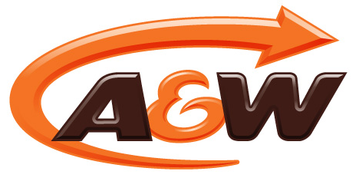

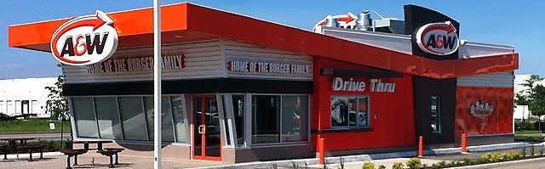
A&W, home of the burger family, first opened in Canada in 1956 with a small drive-in restaurant. By 1966 there were over 200 drive-in A&W locations and today, A&W is Canada’s second largest quick service restaurant (QSR) burger chain. A&W’s success can be accredited to their ability to listen to the consumer and adapt their business practices to continue to meet guests’ expectations. With millennials becoming increasingly important in the economy, A&W paid close attention to the demands of this generation and used this to reposition and differentiate themselves.

One of the biggest changes made focused on the ingredients being used in their food. In September 2013, A&W became the first national quick service restaurant chain to serve beef raised without the use of hormones or steroids.
- Canada’s second largest QSR burger chain
- Over $1 billion in annualized sales
- Over 850 restaurants in Canada
- Canada’s fastest growing burger chain
- 2015 Pinnacle Award-Winner, Company of the Year Winner

A&W Canada
A University of Guelph Sustainable Restaurant Project Case Study

A&W, A LEADER IN THE QUICK SERVICE RESTAURANT (QSR) INDUSTRY
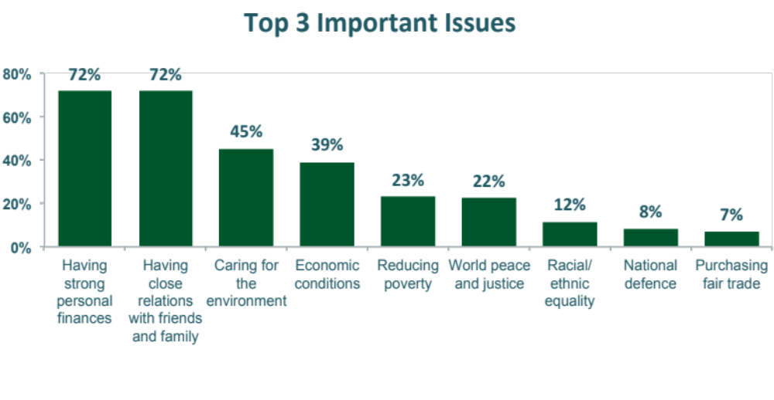
A&W has served their famous Root Beer in a frosty mug since the drive-in days, but the original intention of serving it this way was to elevate the enjoyment of this beverage. As consumers and businesses became more educated, business practices started to change to address and reflect the values of consumers. Looking at millennials in particular, the need to reduce waste became a priority. Today A&W Root Beer is still enjoyed using frosted mugs and because of this, there are 23.7 million fewer paper cups going into the landfills each year. Reducing waste can be especially challenging for quick service restaurants where guests are looking for an inexpensive meal served quickly, but A&W was up for the challenge.

A Company with Sustainable Roots

One year later in September of 2014, A&W introduced eggs from hens fed only a vegetarian diet, without animal by-products. The next month (October, 2014), A&W started serving chicken raised without the use of antibiotics and in January of 2015 they introduced organic and Fair Trade coffee. Most recently, in February 2016, A&W introduced pork raised without the use of antibiotics. Research shows millennials care about the ingredients being used, but also care for the environment and want to support businesses that are taking steps towards becoming more environmentally sustainable.

Just as A&W used frosty mugs instead of disposable cups to serve their Root Beer, they decided to stay true to their roots and see if they could offer guests other types of reusable packaging that not only reduced waste but also heightened the dining experience. With this goal in mind, A&W introduced the now iconic reusable mini baskets for serving side items such as onion rings and russet thick cut fries. Thanks to A&W’s use of metal baskets for sides, there are 23 million fewer paper bags being disposed of each year.

Reusable Packaging
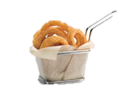
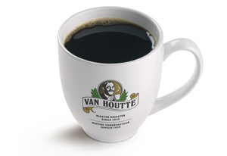
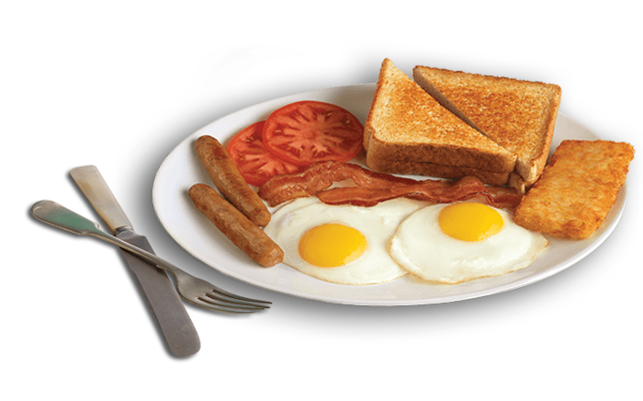
With the success of waste reduction steps taken, it made sense to continue to look for opportunities to reduce. A&W has been serving their coffee in ceramic mugs for a while, but decided to utilize more reusable materials while serving breakfast. A&W now serves their breakfast meals on china plates with stainless steel cutlery in addition to their coffee in a ceramic mug. By serving their breakfast items this way, they are reducing waste each year by:

- 11.5 million paper coffee cups
- 4.5 million paper plates
- 9 million plastic forks and knives

In total, by using reusable packing to serve their food and drinks, A&W has been able to divert over 1 million pounds of waste from landfills each year.

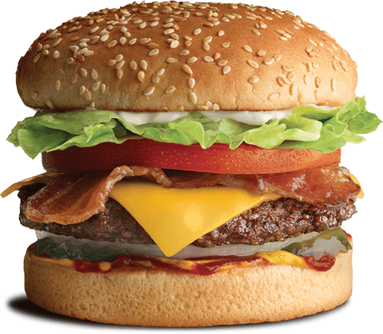
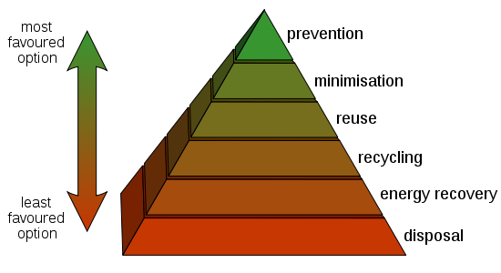
The best way to reduce waste is to not create it in the first place. This is not always a reality in the QSR industry when guest require meals served quickly in packaging that can be easily disposed of when their meal is finished. A&W has made great strides forward in reducing waste for their dine-in guests but wanted to focus on a more eco-friendly solution for their take-out and drive-thru guests.

Since the days of the A&W drive-in restaurants, their burgers have been served in foil packaging. A&W’s goal was to replace an item that went straight into the landfill (foil) with an item that was compostable (paper product). Unlike changing from disposable fry cups to metal fry baskets, replacing the foil bags might have caused challenges in the guest’s experience due to the perception that foil would keep food hot. Dedicated to becoming more sustainable, A&W looked at how they could serve their food using compostable paper without affecting food quality and the guest’s experience.

Compostable Packaging
A&W has reduced waste inside their restaurants by starting at the root of the problem; in this case, they looked at maintaining food quality by exploring how they could get their burgers to leave the kitchen hotter than before. If the food can leave the kitchen hotter than previously, the need for foil packaging could be eliminated. With this objective in mind they invested in an overhaul of their kitchen equipment. After the upgrades in the kitchen, A&W tested the temperature of their food with their new kitchen practices and the compostable packaging, in order to compare it with the heat retention of the traditional foil packaging. The testing confirmed they were able to maintain the same temperature retention and they were able to deliver a hotter burger that stayed hot.

Waste Reduction Pyramid
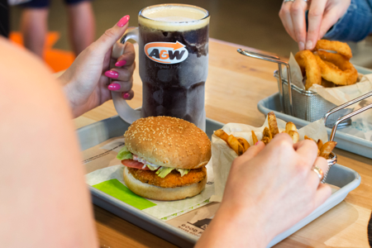
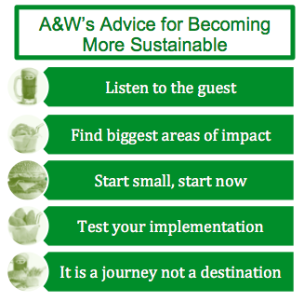
Take Away

Looking at A&W’s success it is clear that the guest experience, improved financial performance, and environmental sustainability can all coincide. Today, A&W has over 850 restaurants in Canada, over $1 billion in annualized systems sales, and is Canada’s fastest growing burger chain. They used the cost savings of switching to wax paper packaging to offset cost of equipment upgrades needed to maintain product integrity. A&W listened when their guests expressed their desire for companies to become more eco-friendly and they made changes to reduce waste. They were able to adapt their strategy when they saw that restaurant sorting options confused their guests, and decided to stay on track with their waste diversion strategy by using compostable packaging. Despite the positive steps taken, A&W knows there is still a lot of work to do. Tyler Pronyk, Director of Distribution, Equipment & Packaging for A&W says “It is a journey and we have only just begun”.

Like many restaurants, A&W tried introducing waste sorting stations so guests could properly dispose of their waste at the end of their meal. What they found was that sorting waste was overwhelming for the guests and often resulted in trays being left at the table opposed to being appropriately disposed of. With guests leaving their waste at the table, restaurants were left messier than previously. Since this effort was not the solution to becoming more eco-friendly, A&W focused on creating a packaging line-up that is exclusively compostable. If everything can be composted, no sorting will be necessary. Currently 90% of A&W’s packaging is recyclable or compostable and the goal is to make the changes so 100% of their disposable packaging is made of compostable materials.

